**Software Design Document**

**AI Meets the Classics**

**Version 1.5 approved**

**12/19/2018**

Edgar Diaz,

Vikram Venkatesh,

Michiele Ogbagabir

**AI Meets the Classics Purpose:**

**Target audience:**

The target audience are users that want to pull up information about the Lord of the Ring book.

**Overall Description:**

The purpose of this project is a representation of the emotions of characters through the chapters as well as the relationship between characters.The program will let the user pick two options a character emotion plot or a character relationship plot.If the user picks character emotion then the program will take in the character and an emotion to then plot the emotion throughout the chapters. If if they pick the character relationship plot then the program will ask for the two characters of which you want to the relationship between them. The data will be based on the amount of times that the character is associated with an emotion. This data is being retrieved from an elastic search of the Edison data which tells use the frequency of an emotion as well as the relationship between character and allow us to link it to a character.

**Project Goal:**

The goal of this project is to use the data generated by training Edison to recognize emotions and themes and use that data to represent the emotion of a character throughout the chapters. We will be able to see the progress of a character’s emotion throughout the chapters and how the character emotion changes throughout each chapter and we could use that data to show a link with an action that has been taken.

The project will also be able to generate a relationship plot between two characters and allows us to track their relationship throughout the chapters.

**Possible Applications**

This data can be used to generalize (i.e interpolate and extrapolate) what's action a character would take based on their emotions or the relationship with other characters throughout the chapters. (e.g if the character is angry at an average of 60% throughout the chapters we can come to a possible conclusion whether or not the character will fight or not.)

**User Interface:**

The user interface will be an input screen that will prompts the user to pick an option to either plot the character and an emotion, or to plot relations between two characters throughout the chapters. The program will then it will use an elastic search to get data from Edison and retrieve the information needed to populate a graph of the characters emotion throughout the chapters as well as the character relationships.

**Example images:**

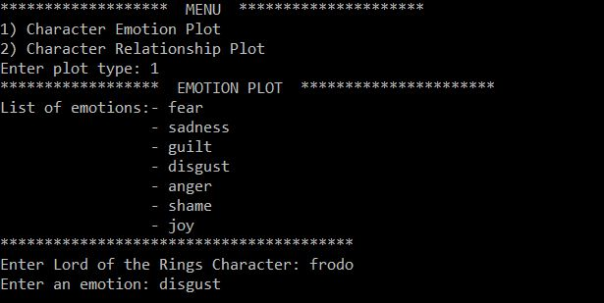

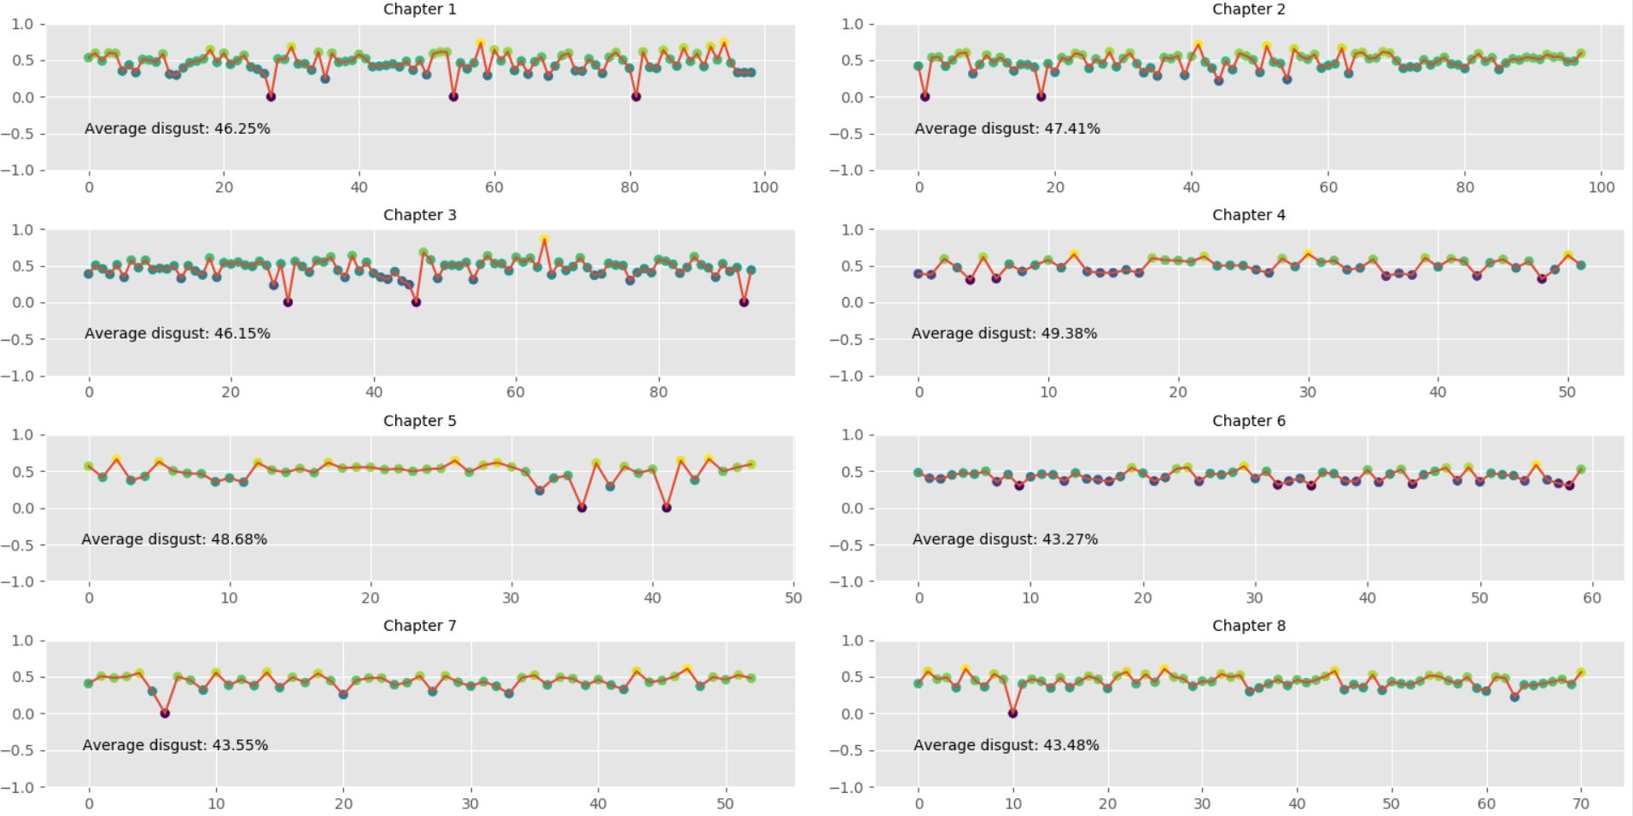

As seen above, on selecting the character emotion visualization and on selecting the character Frodo and emotion disgust, we get the plots for each chapter showing the amount of disgust Frodo feels at various points in the chapter and the average disgust in the chapter for Frodo. The above plots show only for the first eight chapters. We get plots for all twenty two chapters.

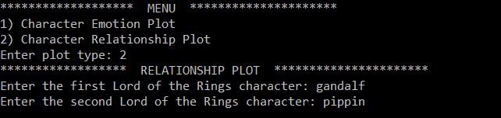

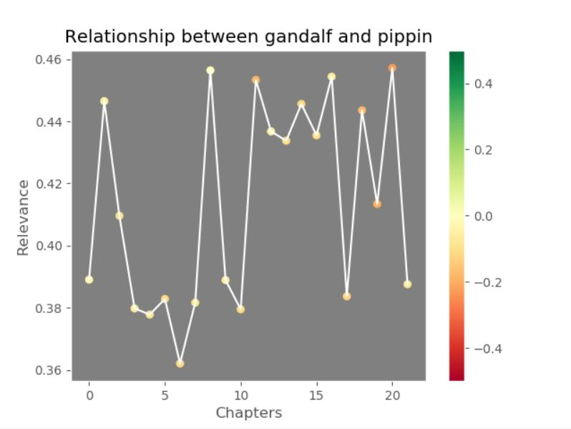

As seen above on selecting the visualization character relationship plot and on selecting the characters gandalf and pippin, we get a plot of the relationship between the characters as the chapters progress.

**Program flow:**

|  |  |
| --- | --- |
| **Function/method** | **Description** |
| **Get data** | Takes in the characters name and the emotion to process |
| **Process data** | Takes the data and passes it to Edison |
| **Print graph** | Useses the data from what Is returned from Edison and plots the points on a chart |

